GDD „A Warring State“

- Game Design Elective -

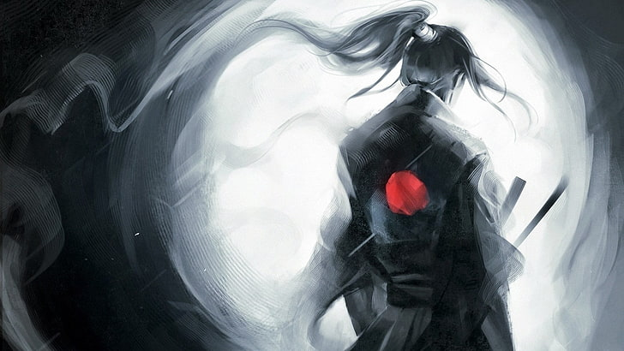

Created by Umberto Falkenhagen

Student-No. 428796

Summer semester 2021

Hanze University of applied science

List of contents

OnePager 4

1. Executive summary 5

1.1. Gameplay summary 5

1.2. Goals 6

1.2.1. External Goals 6

1.2.2. Internal Goals 6

1.2.3. Gameplay goals 6

1.3. Summarized Product details 7

2. Moodboard 8

3. Dramatic Tools 9

3.1. Theme 9

3.2. Mood 9

3.3. Form & Style 10

3.4. Plot 11

3.5. Pacing 12

3.6. Visual Experience 14

3.7. Immersion 15

4. Gameplay 16

4.1. Gameplay flow 16

4.2. The Base / Character Menu 16

4.3. The Missions 17

4.3.1. Core Mission Gameplay 17

4.3.2. Level Structure 19

4.3.3. Challenges 21

4.3.4. Puzzles 22

4.3.5. Player Progress & rewards 22

5. Worldbuilding 26

5.1. World rules 26

5.2. Gameplay rules 26

5.2.1. Base Gameplay Rules 26

5.2.2. Mission Gameplay Rules 27

5.3. World Content 28

5.3.1. Item placement 28

5.3.2. Scripted Sequences 29

5.3.3. AI/Actor placement 29

5.3.4. Symbols and Icons 29

6. Mechanics 30

6.1. General Mission Flow 30

6.2. Turn-Based System 32

6.3. Ability cards 33

6.4. Other mechanics 34

7. The Prototype & Future Development plans 36

7.1. Controls 36

7.2. Future Development Plans 37

Sources 39

Cover 39

OnePager 39

Moodboard 39

Dramatic Tools 39

Mechanics 40

Prototype 40

# Ein Bild, das Text, Zeitung, Quittung enthält. Automatisch generierte BeschreibungOnePager

# Executive summary

It is the Sengoku Jidai – the period of warring states. A time of civil war in Japan and the time we mostly think of when imagining Samurais and Ninjas. A time where the fate of once mighty clans can change within days, a time of great self-sacrifices and bravery but also of treachery and betrayal.

The protagonists name is Hattori Hanzo, a ninja, who serves his lord Tokugawa Ieyasu, whose father once saved him from death and raised him like one of his own. In that role he must carry out missions and help his lord to rise in power. While being raised as a law-abiding person, who takes it as an honor to serve the higher ranked classes, he soon starts to see the world through a different angle. Even though his lord promises much gain for his service and tries to what is best for the country, he will soon recognize that everything has its price. Becoming more and more entangled in the chaos of war, the once so seemingly clear differences between what is right and what is wrong will soon start to fade away…

* The game aims to give the player a feeling of disturbances of war. The goal is to have the player immersed in a way that they must make tough decisions and think of what is best for them and what is best for the country.
* Story-heavy, focused on the rising of Ieyasu Tokugawa (future Shogun (ruler) of Japan.
* Meant to show the consequences of war for the people.
  + E.g., Losing family members, homes destroyed

## Gameplay summary

* Core Gameplay: Stealth and Souls-like with using a card-deck for abilities.
* Third person view with heavy focus on strategic gameplay (similar to games like Desperados or Shadow Tactics)
* Playing as a ninja, the goal is to get through the levels without being seen.
* Gameplay loop consists of getting a mission in the base (which also acts as kind of character menu, to change skills and equipment) and carrying out the mission in separate level.
* Cards are serving as the depiction of special skills; a deck is built by the player to contain abilities that serve the players playstyle and mission circumstances.

## Goals

### External Goals

* Creating a portfolio piece
* Creating an interesting mix of strategy and souls-like/stealth elements
* Advance level- & game-design knowledge
* Getting better with Unity

### Internal Goals

* Make the player feel the inner conflicts of the character and think about conflict of values, like loyalty vs honor. (“A warring State” relates to the civil war but also, if not even more, to the inner conflicts of the character)
  + The player should not just feel that “war is ugly” but rather how the character is torn between his will to change the country to something better but the question whether this can even be achieved with violence and war.
* Give the player a feeling of control while not making the level “predictable”.

### Gameplay goals

* Player creates a character that is adjusted to personal interests (e.g., fighting style, different abilities)
* Player must find a delicate balance when using their abilities.
* Player must deal with circumstances of the level in a creative way, developing strategies and cunning moves.
* The players main advantage over his enemies is their intellect, not their strength in combat.

## Summarized Product details

**Game title:** “A warring State”

**Game System:** PC for now, though the concept is not platform bound.

**Input System:** Gamepad (though keyboard is partially implemented as well)

Engine: Unity

**Target audience:** 16+ years old; **fans of small-group strategy** like Divinity Original Sin, Desperados, Gears Tactics, XCOM & **stealth games**, like Shadow Tactics; fans of Japanese history

**Genre:** Stealth/Souls-like RPG, that uses (a somewhat) turn-based strategy system and mixes parts of a card game into the experience

**USP’s:**

* Unique combination of Card-, Stealth- & Strategy-Game elements
* Immersive story focused on the disastrous consequences of war instead of glorifying it.

# Matt Lara - Sengoku JidaiSteam Workshop::CK2 NMIH Sengoku Jidai (15 MODS) [06/16/2020]Moodboard

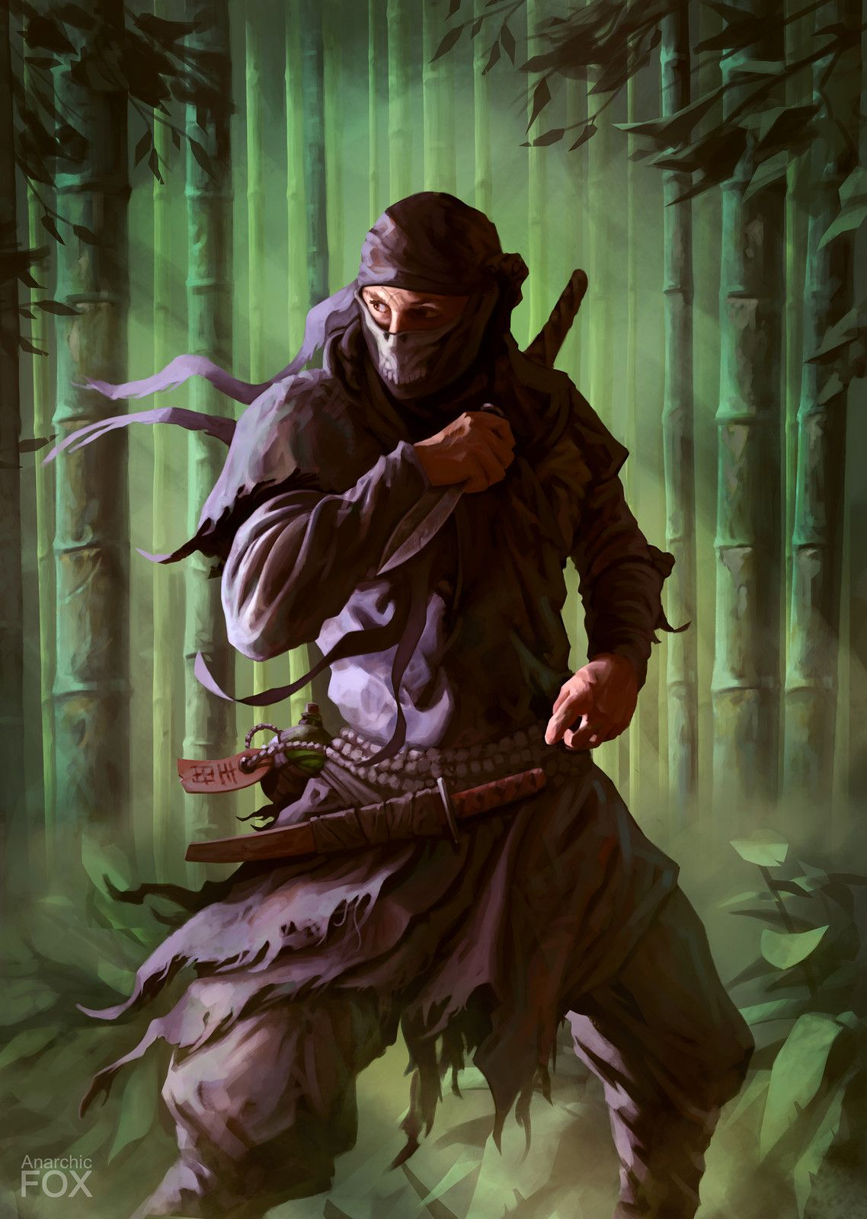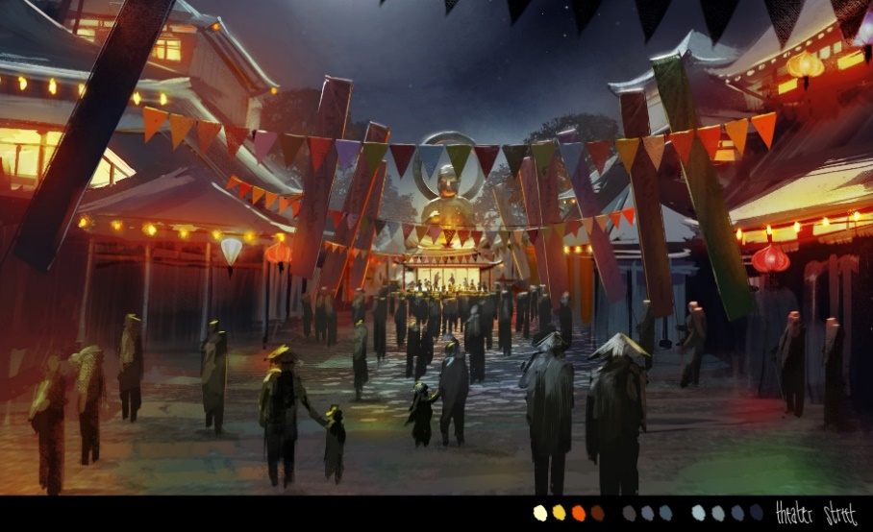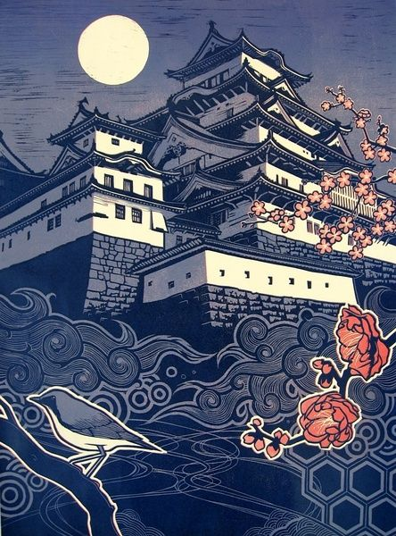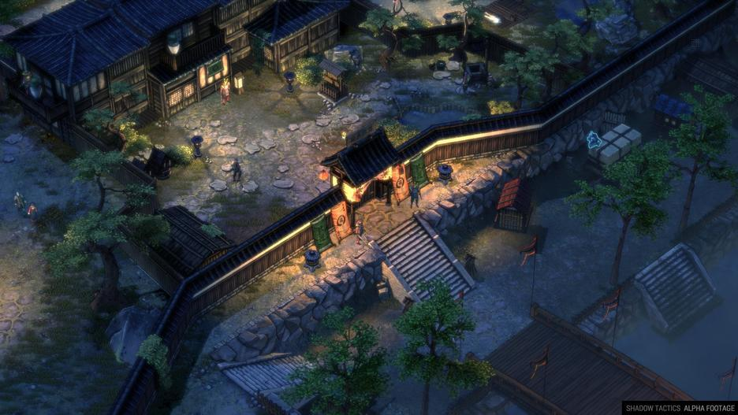

# Dramatic Tools

## Theme

* Japan 1500 – 1600 (approx.)
* Civil war; the player is on the secret side of war, deep within enemy lines
* Age of samurai (nowadays glorified as honorable warriors)
* *Beautiful Japanese architecture and culture + brutal, merciless war*
* Generations have known nothing but war
* ***‘People fight for peace’***
* *‘Don’t show them mercy as they will show non to you’*
* Warlords (‘Daimyos’) who are not afraid to sacrifice their people for power
* 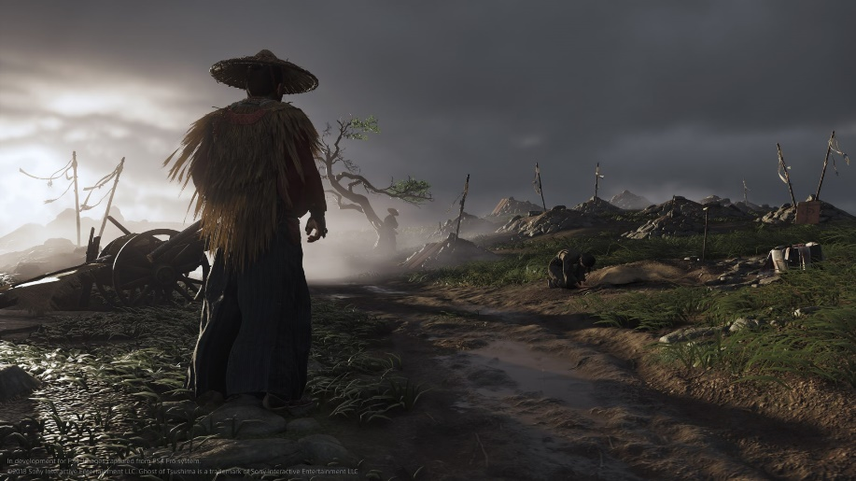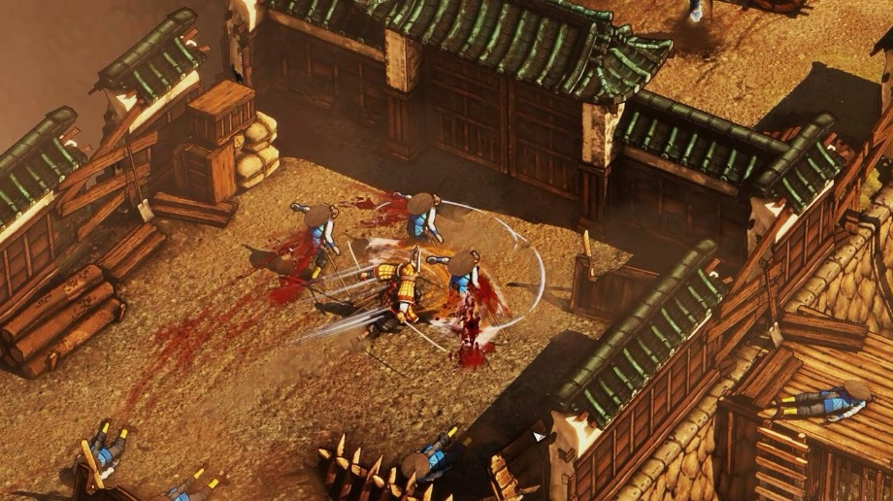Fight for survival vs. living a honorable life

## Mood

* Warlords get more powerful in exchange for suffering of their people (mostly for civilians)
* Justified by the honor & glory of fighting and dying for their lords
* Huge armies and mighty castles vs. battered villages and poor peasants
* Giving ‘a deal with the devil’ emotions, which relates to the protagonist doing bad things (and mentally suffering from it) while believing in a higher good
* A permanent conflict between the ideology of believing in the existence of a code of honor vs the decay of all moral standards after generations of people have known nothing but war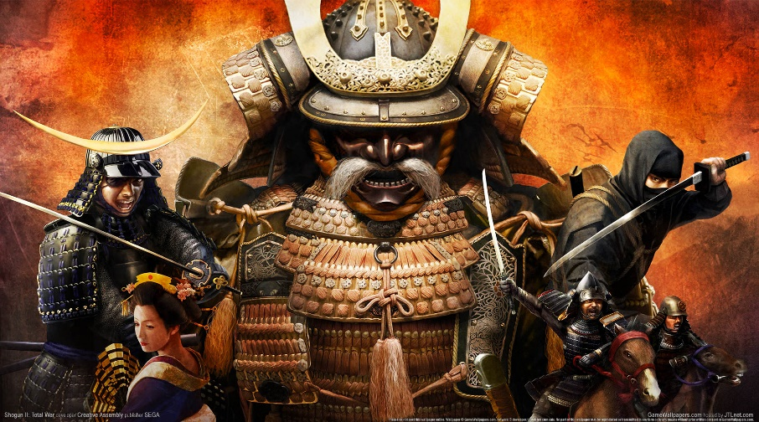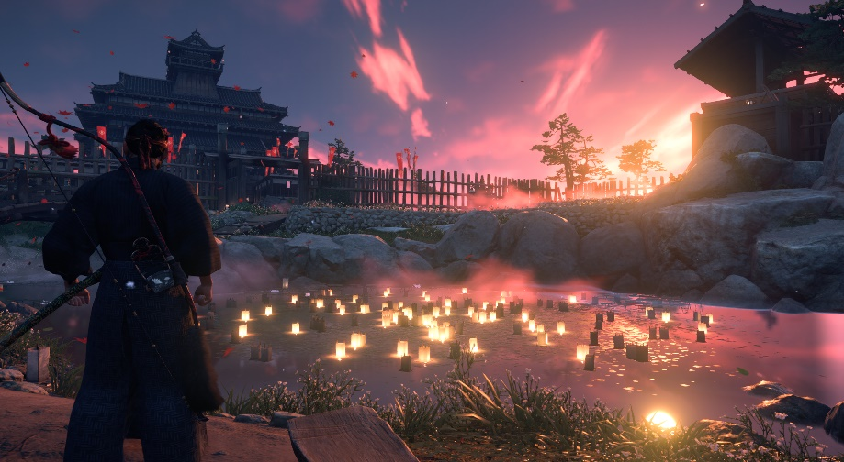
* Tradition are being overthrown by new types of warfare (e.g., night attacks have never been used as a meaning of warfare, introductions of arquebus vs the traditional samurai warfare)

## Form & Style

|  |  |
| --- | --- |
| Form | Style |
| Discussions of characters (NPCs) in the level | Display of different opinions on the war (NPCs talking about hopes, dreams, family, etc.) – make it a tough decision to take someone’s life |
| People (prisoners) being executed | “War will make corpses of us all.” (Faramir, LotR), Soldiers who have dreams and hopes themselves have no mercy for the other side |
| General giving a great speech about the honor of fighting for the enemy clan | Enemy soldiers seem to have pretty much the same motivation to fight for their lord as the main character |
| Inner monologues of the character throughout the levels | Display the inner conflicts of the character, display emotions (negative and positive) |
| Banners and colors of the local clan | Strengthen feeling of being in enemy/friendly territory |
| Civilians being abused and raided from all sides | Suffering of the poorest is worth it for a higher good? |

## Plot

Throughout the first act the character (Hattori Hanzo) will form a stronger bond with his lord (Ieyasu Tokugawa), feeling that he is a Daimyo, that is different from the others and who is trying to protect his people by forming alliances. This is also the act that is currently described in the beat chart.

It starts off with the destruction of Hanzo’s home village and the survivors being secured by Ieyasus father. *This establishes the characters great longing for peace as he has suffered indescribable losses while also forming a strong bond of duty towards the Tokugawa clan as they saved his life.*

After that comes the introduction to the Tokugawa castle which should give a real feel of safety (kids playing, well-protected civilians, peaceful atmosphere) and is something that he will want to protect in the future. *Also, this will serve as a base for most of the game and should become something like a new home though it might be taken away from him somewhere throughout the game to amplify the characters internal crisis.*

The 3rd level then introduces Ieyasu, who is held captive at a temple of the enemy clan (Oda). Hanzo is send by Ieyasus father (currently dying) who fears that he might be killed by the Oda when the Imagawa (allies) attack the castle as a meaning of ‘burned soil’ but Ieyasu refuses as he believes that if he flees the Imagawa might not believe in their alliance. Instead, he hopes to be ‘rescued’ by the Imagawa and through that establish an alliance with them after his father’s death (as they feel that he is in their debt) and through that give more protection to his future people. *This should be the base of Hanzo’s believe in Ieyasu as he knows that Ieyasu is ready to risk his own life for his people.*

The 4th level will be a few years later *(maybe some other missions can be inserted before it to further form the bond between Hanzo and his master*) and will be part of the campaign of the Imagawa, supported by Ieyasu and his clan. Hanzo has the mission to spread some disinformation between the Oda leader and his subordinates to make the siege of a border castle for Ieyasu and his men easier. He will start off with the feeling of getting a long-awaited revenge as his mission is to exchange a letter to the castles commander who is supposed to defend the castle until the Oda forces can come to support them but instead the exchanged letter will order him to leave the castle and come to the Oda military camp. Ieyasus hope is to ambush them then on the way and by that eliminating the Oda forces without their defenses. Hanzo will be happy to do that at first as the castle’s commander is the same one who has raided his village years ago. Throughout the level however Hanzo will come to know that there are also a lot of civilians in the border castle who will travel along with the troops and will be killed in the ambush. *This will start the inner conflict of what is needed vs what is honorable.*

The 5th and final level of the first act *(again some levels could be inserted before that to further illustrate the bond between Ieyasu and Hanzo but also to amplify his inner conflict)* will be a turning point of the campaign as the Imagawa forces are resting in a gorge, preparing to take the last Oda castle. During the night, the soldiers are celebrating the close by victory and Hanzo (who is in the camp as an emissary and to inform Ieyasu, who is in a close by border fortress, when the troops are making ready for attack on the next day) overhears some discussions that make him doubt that these soldiers are much different or more honorable than the Oda soldiers. Then, the camp is attacked out of the dark by the remaining Oda forces. It is mayhem and as the Imagawa forces are being slaughtered and routing, Hanzo must escape. After the Imagawa have been crushed, Ieyasu switches sides and the Oda Nobunaga becomes his new ally and superior.

In the second act this bond will be put on the test when he must perform more and more critical missions that are aimed for a higher good. These missions though ordered by Ieyasu come from higher authorities and are more kind of a compromise between the lust for power of Ieyasus superiors and his goal to protect his people by not causing his superiors anger and distrust. Hanzo will see a change of Ieyasus character as he seems to become more and more hungry for power though it is justified that only more power for Ieyasu can protect his people from the growing dangers.

In the final act this change of character will become completed as Ieyasu rises to enormous power and while Hanzo sees that Ieyasu could be the one to unify Japan, he questions more and more on what cost this happens.

## Pacing

The goal is to achieve a pacing that makes the player understand that his lord has good intentions but question more and more whether this is the right way. As mentioned in the Form & Style chapter this conflict is created by knowing that the characters actions serve a higher good while facing a reality in which **opposing sides fight each other** as they are **trying to achieve basically the same thing.**

Though there are different ways to approach a level with different ability types (e.g., distracting enemies vs stealth-killing them vs finding ways around them, like secret passages), the pacing should always be linked to a feeling that every action has consequences. The player should be able to have an impact on the pacing by using mechanics to their advance. For example, using the mechanic of disguising as an enemy may make the player less flexible as their abilities change according to the character they disguised as and by that increases the pace because they can walk by some enemies and get through the level faster but must fear that they are caught in a more difficult situations with bad equipment and abilities (should give some adrenalin).

In general, however the game aims for a slow pace to underline the things happening around the character and relating to the fact that the game is a stealth game in the first place. Good planning of the players actions is promoted and should be rewarded in contrast to running through the levels and acting like a slaughtering hobo. After all the player is not some overpowered hero that can easily take on fighting multiple enemies at the same time, they may be a well-trained ninja but that means acting cautiously and not drawing to much attention – even better not causing any commotion at all.

*The Beat Chart for the first act*

## Visual Experience

In general, the game should have an art style similar to games like “Desperados” or “Shadow Tactics”. This could be described as a closely realistic art style with painting elements (much like in other anime games). This is supposed to achieve a mixture that gives everything a feeling of the character telling his story in a Japanese manner.

While having a good part of the missions being carried out in the dark to imply the need of secrecy and give an imminent feeling of danger there will be also be a good part of daylight missions. These missions are thought to show the daily life in the castles and villages and display that even though these people are enemies, they are not different. The goal is to show that they are facing the same issues of injustice, suffering from war, etc.

When carrying out night-time missions the use of light and darkness will also contribute as a strategic factor, which means that darkness can offer some form of hiding options but can also be an obstacle as the character obviously does not have night vision. As in most stealth games it will also serve as an option to confuse enemies etc. On the one hand this means that the player will most likely avoid walking in light cones as they reveal him to the surrounding but on the other hand, they sometimes will need the light as well, for example he will not be able to read a map in the darkness and performing actions like breaking a lock has a lower chance of success when performing it in the dark.

In terms of violence, it is important that there are no special effects, like in anime fighting games. Of course, there can be explosions and a distinguished look when performing abilities, but it should always be realistic and in relation to the act that is performed (e.g., the ninja will kill somebody quickly instead of first pulling his guts out, tearing of the enemy’s arms and then cutting off his head…). There can be a lot of blood but if so, it should also relate to some kind of obstacle if some other guard sees it on the ground. After all, the goal is to leave as few traces as possible and to act secretly.

## Immersion

The whole game’s goal is to immerse the player – obviously. For that it uses mainly two ways: Cognitive dissonance and the need for self-deception. The players should feel their own values being questioned when the characters moral standards collide with the urge to achieve a higher goal. Still, they can experience the brutality of war in a safe environment (a game).

# Gameplay

## Gameplay flow

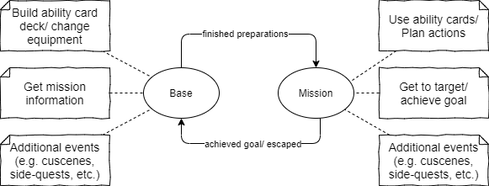

Figure 1: Overall Gameplay flow

As mentioned previously, the gameplay cycle will consist (mainly) out of preparing for a mission in the base (choosing abilities & equipment and getting mission details) and executing the mission. This can be seen in the flowchart.

## The Base / Character Menu

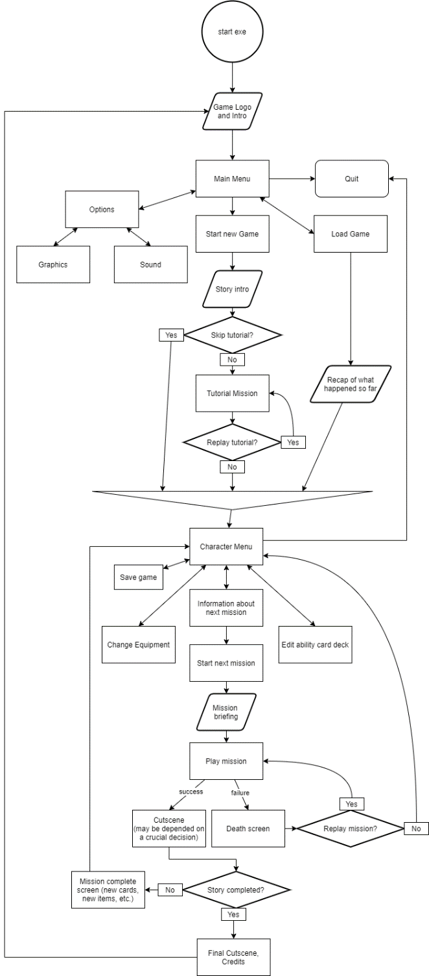

Figure 2: Gameplay Flowchart

The gameplay within the base will be easy and more like going through a *character menu (it is also just mentioned as the ‘Character Menu’ within the flowchart),* just with a different visualization. However, things like cutscenes, side-quests, etc. could be included.

In general, the gameplay within the base should translate to being home and safe and give the player some impressions of the progress they make throughout the game, meaning when there are preparations for a battle the atmosphere might be much different then when there is ‘relative’ peace. The base might also change entirely through the game like when they are on a crusade and therefore stationed in a military camp.

The goal of this visualization is to further immerse the player instead of pulling them out of the game when they are not on a mission.

## The Missions

The missions will be the core part of the gameplay. They will include most of the mechanics (e.g., stealth-gameplay, card/turn-based system, etc.) and depict the development of the story step by step. The missions (in combination with returning to the base in-between) will be structured in a linear way. This follows the logic that the protagonist, after all, is just a servant and gets assigned to missions. However, within each mission there will be several options to achieve the goal of the mission, resulting in a semi-liner level structure. In addition to that (but depending on the mission) there might be some kinds of side quests, that allow some way of decision-making. These side quests will still be contributing to the main story of the mission but allow the player to change the outcome, even if it is just a little bit.

### Core Mission Gameplay

The main parts of gameplay within each mission are:

* Stealth gameplay

The most important rule for the player is not to be caught on their mission. Their goal is to act in secrecy, not causing the enemies attention. Though this does not mean combat is impossible, the player should always act cautiously and plan their actions properly.

* Ability cards

These cards depict different abilities of the character and will be discussed later in more detail. Summarized, the most important things to know about them is that the player can build their own card decks priorly to every level. Through that they must make several decisions before every mission as the assembly of their deck has influence on which abilities they can use (based on chosen cards), how likely it is to draw this ability card and how often they can use this ability in total (based on the number of instances of one card within their deck).

* Planning

The player must analyze the mission and plan how to act efficiently. To some extent this happens already before the mission starts, as the player already gets some information about the mission and builds their deck. However, the player also must plan their actions within the level. The foundation of this planning is a turn-based inspired system for the missions. Though the structure of this system will be explained in more detail later, the most important elements of it can be seen in the ‘Mission Flowchart’ and are as following:

* Every mission has a total max amount of ‘turns’ to complete the mission.

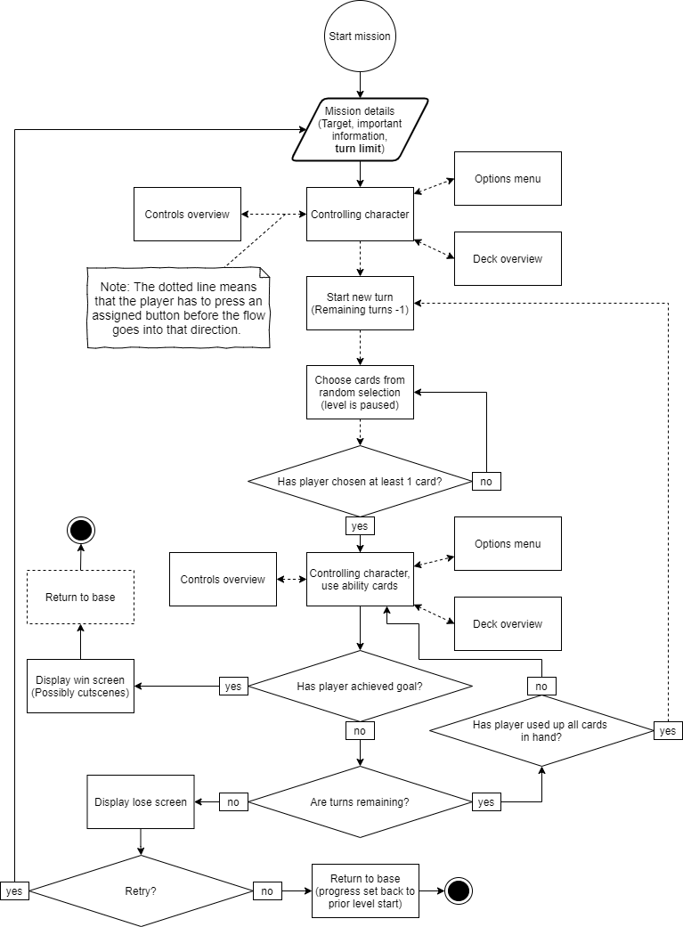

Figure 3: Mission Flowchart

* A ‘turn’ basically consists of choosing a range of ability cards (always at least 1 and up to a certain amount based on the difficulty that the player has chosen for the game) from a random selection.
* Using all chosen abilities as efficient as possible or discarding them in case they cannot find a good use for them.
* Starting the next ‘turn’.

Together, these elements are the main ingredients to create a unique gameplay feeling for the player. They work also towards the goal of giving the player the feeling of control while not making the levels predictable. Of course, there are other elements within the game that are important. But in the end, they should always be supporting these elements in one way or another. Some of these elements that further extend or deepen the gameplay are:

* Interactive Environment

Making the Environment very interactive supports the ability-card- as well as the turn-based-system. It is important to give the player different options to approach the level. Examples of it could be ability cards like a grappling hook, using ziplines (which would be reoccurring elements within the levels) or doors that can be opened with a lock picking ability.

* AI with different behavior and skill sets

The AI should also not only allow different approaches, but even demand it. This relates heavily to planning as the player should be able to identify different enemy types and act as efficient as possible to get past them.

* Side quests/ additional events

As this element was already mentioned several times, it is obvious that it supports the general gameplay in many ways. On the one hand it allows to give more options to the player, for example by offering additional information about the primary target/goal. On the other hand, it adds up to giving the player the possibility/feeling of influence over the development of the story.

### Level Structure

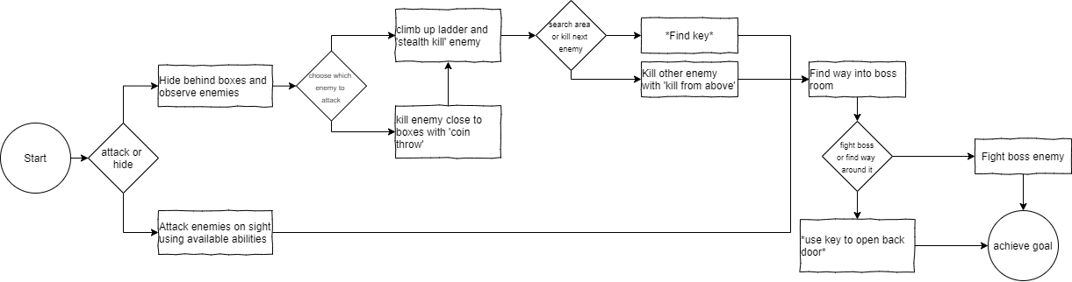

Figure 4: Example level structure

As already mentioned earlier, the missions will follow a semi-liner level structure, meaning that, even though different approaches to certain parts of the level are possible and intended, the player will meet different ‘choke’ points. This relates to the circumstance, that this story is always linear, following fixed events (maybe some small twists, depending on some influential side quests). The chosen level structure aims to, even with these boundaries, allow different playstyles, strategies and to also increase the replay value.

The annotated map should give some visualization to that. It shows how different playstyles/approaches to the mission are allowed, while narrowing it down to 2 different ways to get into the final room and then ending up with all approaches delivering the same outcome. Of course, this is just a very small/simplistic example that refers more to the earlier missions of the game. Throughout the development of the story this should become much more complex. Also, as mentioned before, the goal is always to give the player a feeling of influence over the events and it is especially important to balance different approaches properly to motivate the players to try approaching those missions in different ways.



Figure 5: Annotated map example level

Keeping that in mind, the beat chart (as seen in ‘3.5. Pacing’) shows that it is important to connect each level to the current story events, meaning that the circumstances should vary, for example if the story demands the players actions to be not noticeable by the enemy it could relate to the mission’s goal being to achieve *something*, **without** killing anyone. This should force the player to not only follow their one favorite playstyle, but to adjust, just like a good ninja would do as well.

Likewise, the flowcharts (especially the ‘Mission Flowchart’) show that the missions are by no meaning supposed to be easy. There should always be a challenge and dying and retrying a mission or even going back to the base to change elements like the deck assembly or trying to gather more information are crucial to the gameplay (so trial and error is part of the game).

### Challenges

Of course, challenging the player is important to the game. Since it is a stealth game, that mixes in rogue-like, as well as strategy elements, it only comes in naturally to have players with a rather high skill level. After all it is about playing cautiously and avoiding that the players feel like they have the absolute upper hand in a level. The fear of being caught should be imminent.

Still, when thinking of the random factor that comes through the card-game mechanics, it is important to not make the challenges to hard as the players might feel that they are losing not because of their own faults but because of the randomness (they should not be presented with unfair challenges, so to speak).

Adding those little side-quests, that allow the player to change the outcome of a mission with minor twists, also aims to empower a feeling of having influence on the story. This should help to avoid a lack of meaning while the story is mostly linear.

Another thing that is especially important is the number of missions. Although, there should be enough missions to offer enough variation, every mission should be chosen carefully, as they should all contribute properly to the main story to avoid prolonging the story with useless activities. This relates also to the fact that the player cannot really chose their missions. So, adding missions that feel irrelevant to the player will risk that they become desensitized. If the number of missions needs to be increased even though the story is already filled with the already existing missions, then it might be better to offer those extra missions as optional to the player.  
After all, the target group consists of players who like a more challenging games and adaptation (through ability cards and proper planning) is really part of the process when playing.

### Puzzles

When thinking of puzzles within the game it first comes to mind that the level themselves are big puzzles. Going through a level means analyzing enemy movement patterns (pattern recognition), using the environment to the own advantage (abstracting a problem) and using the given ability cards to the most efficient extent or being creative with them (lateral thinking). This combination of puzzle elements already offers an interesting approach to create challenging and interesting environments. However, the challenge (level design wise) is to transfer those elements into the game’s world. The puzzles should be happening subconsciously.

One thing that is also especially important is that the puzzles should seldomly have only one correct outcome. This relates again to the random factor of the ability card mechanic. There should be different ways to complete a ‘puzzle’ as it would be very frustrating if the player lost a level only because they “don’t draw this one crucial card”.

Keeping that in mind, puzzles could still serve to divide missions into different smaller parts. An example could be that while trying to achieve the primary goal, the player can use a secret door. To do that however, they first need to get the key for that door, which is in a room that can only be accessed when tricking the guards away. Through splitting the big puzzle into smaller ones, it might get easier to create a level that doesn’t display those puzzles to obvious and in an interesting way.

### Player Progress & rewards

As the player progresses through the game, they will receive more abilities and change their equipment (which is more passive, giving certain values to the player, like faster movement, increased jump height, but also things like a special ability card that is only available carrying this equipment, like bow abilities only being accessible when a bow is equipped).

With that in mind it is important to think of what kind of feedback the player will receive.

On the one side the player will receive positive feedback, awarding the use of abilities in general. However, they always have to think of possible positive or negative examples related to their playstyle.

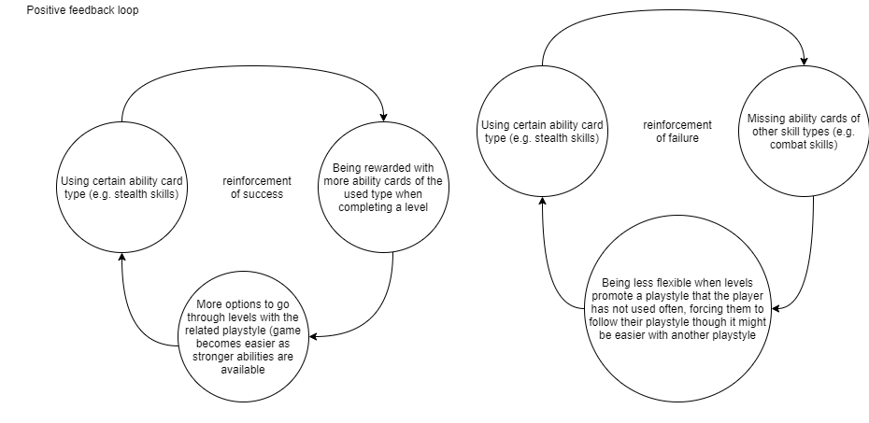

Figure 6: Example Positive feedback loops

The given example illustartes that more clearly: If a player prefers a certain ability card type, they will be rewarded with more cards of this type (relating to some kind of a skill tree), which, on the one hand, allows them to use a more diverse and even stronger set of cards of the chosen ability type. However, this also comes at a price since they might be less flexible when a mission does not promote using this ability card type.

Should a player decide to use a lot of different abilty cards and types instead, they will become more flexible but face the issue that they are advancing more slowly within the used ability card types (/skill trees), which is shown in the negative feedback loop example.

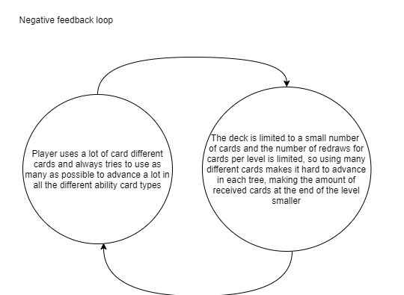

Figure 7: Example Negative feedback loop

However, it can be said that the progress of the player, relating to the ability cards they receive is dependent on the playstyle they prefer. Every ability card will be assigned to one of the ability card types, which are equivalent to skill trees in other games. And depending on the number of cards used of a certain type and the player progresses after each level within that card type and is rewarded with new abilities. The example of different types (one type having the same color) should illustrate that, but it should be noted that this is just a sketch to show how a player is rewarded with stronger abilities while progressing and by no meanings close to a final version. The game should include much more cards and maybe even subtrees within the types.

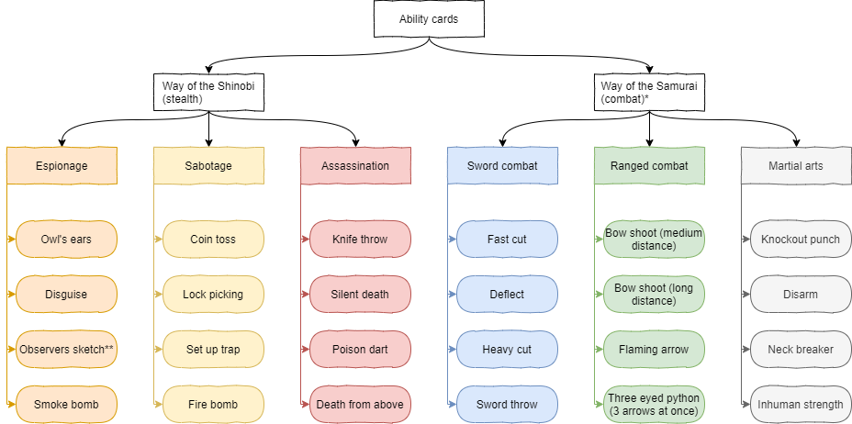

Figure 8: Example ability card types

Something that I have not thought about deeply yet, to be honest, is how the equipment of the player should be linked. There are different options, however, but which one fits best depends on the further development of the game. After all, it comes down to 2 options (from my point of view), which I wanted to mention here:

* Classic loot system

While going through the missions the player will be able to collect equipment from enemies, chests, etc. and later equip them in the base. They could also be able to collect different components/materials to later craft equipment in the base.

* Equipment linked to story events

This would make the equipment even more passive, meaning that the player will receive different equipment and certain points throughout the story. This would mean that the equipment must be chosen and carefully in relation to what is being told.

As I said, it is up to the further development of the game, but to summarize it, the way the equipment is used in the game should again support the other gameplay aspects.

# Worldbuilding

## World rules

According to the linear main story and the semi-linear level structure, it is possible to define most important rules for this world:

* The player CANNOT change the outcome of the story (in general)

But

* The player CAN change how the character is placed within the story events (e.g., does he blindly follow his orders or does he try to help some civilians)

As mentioned earlier this happens through optional side-quests that relate to the protagonist’s feelings and moral standards and depend on the story of each mission. There could also be bigger consequences, following one of the players decisions but the final outcome should always be that Ieyasu Tokugawa rises to power.

## Gameplay rules

In general, there are two different gameplay settings – the base and the missions. As described in the Gameplay chapter, there are different actions available in both settings.

### Base Gameplay Rules

Within the base the characters actions are much more limited. Still, the player will be able to have the common controls over the character (moving, sneaking, running, jumping, etc.). It might be interesting to also include the currently chosen card deck in some way to offer training options to the player and to try out different usages of cards. In difference to the missions the deck will not shrink with every used card and they have no limit of turns. However, since the players are at home in the Tokugawa castle, certain ability cards like knocking out / killing people will be blocked and the use of cards that damage the environment like a firebomb should be limited.

Something that is unique to the base is that the player can use interactions with different NPCs to access character options, e.g., deck building, crafting/changing equipment, receive mission details.

### Mission Gameplay Rules

Starting a mission offers a lot more freedom to the player. They will be able to use the general control and now also the ability cards to their full extent.

Along with this change they will now also be able to interact more with the environment, e.g., destroying certain parts of the environment. Also, the other cards which uses were restricted earlier are now open to use.

The following table should give an overview of the most crucial Rules/Actions as well as some abilities that should give an example to how ability cards can be used in different ways:

|  |  |  |  |  |
| --- | --- | --- | --- | --- |
| Action | Can | Cannot | Player Reaction | Environment Reaction |
| Player Action 1 | Player can sneak | x | Player moves at certain sneaking speed | Depending on the ground they are walking on different sounds are played at very small volume; no reaction of NPCs that don’t see the player |
| Player Action 2 | Player can run | x | Player moves at certain running speed | Depending on the ground they are walking on different sounds are played at louder volume; NPCs that are in hearing distance might be attracted to the sounds. |
| Player Action 3 | Player can jump | x | Player can jump half of body size up and depending on the move speed up to 4 meters further | When the player lands you hear a small thud + sound depends on the ground the player lands on, volume on the height the player is dropping from. |
| Ability card: Coin toss |  | Collect tossed coin again | Player throws a coin up to 15 meters | Coin makes a noise, attracting the closest NPC within an indicated range (4 meters) and distracting them for 5 seconds, once they reached the coin. |
| Action | Can | Cannot | Player Reaction | Environment Reaction |
| Ability card: Firebomb | Place a firebomb that explodes after 15 seconds | Throw the firebomb | Once the ability is activated the character moves towards the chosen point and takes 3 seconds to prepare the bomb | When exploding the bomb sets priorly indicated flammable objects with range of the explosion (also indicated) on fire.  Only certain objects* can be set on fire. |
| Ability card: Fast cut | Strike an enemy, killing or wounding them | Destroy environ-ment | If the ability is too weak to kill the enemy, the character will indicate that by mentioning that this won’t be enough to take the enemy out. Once the ability is activated, the character will move towards the enemy and perform it. | The NPC takes damage and - if the damage is high enough - dies. Some blood will remain at the position of the fight. If the NPC died, the dead body would remain there unless the player hides it somewhere. |

## World Content

### Item placement

Relating to the rest of the current concept (where the loot/equipment system is not decided yet) one can only make assumption on how the item placement will look like. Pickups and powerups will most likely not occur, at least not in the way of loot. However, rewards and collectibles seem like a better approach to me. By placing certain objects on the map, that offer more alternatives to reach the target or more information on the rest of the level, they might help to lead the player, especially in the later part of the game, where level might get much more complicated.

Using certain items to tell the story of the game will also be quite important for the world. After all, the player should feel that they are in a world where a civil war is raging brutally. This could mean that they see a blood, maybe a village that was just attacked by marauders or other things that make them feel unsafe.

### Scripted Sequences

Scripted sequences will be quite important and will consist of in-game sequences and cutscenes that have a “painted” art style (which means that they not rendered videos, but paintings that show the ongoing events)

While the cutscenes will happen when switching between base and level, the in-game sequences will happen throughout the game to further illustrate the world (e.g., a general motivating his soldiers, a group of civilians being executed, etc.)

### AI/Actor placement

As a result of the Gameplay loop between base and levels the contents of both parts may vary a lot.

In general, it can be said that most of the friendly NPCs will be placed in the base while nearly all enemy NPCs (soldiers) will be found in the levels. However, there will also be neutral NPCs that will in most cases be civilians. Starting from these 3 categories they all fulfill different roles within the game.

Friendly NPCs are especially important to the main story, as they will be the ones that the player interacts with in most cases. They will give them advice, be involved in the missions, etc.

Enemy NPCs are soldiers most of the times. That is why they should be diverse, with different enemy types, that have different weaknesses and strengths. They will also be included into the scripted sequences.

Neutral NPCs will mostly serve as props to the world. They will help to illustrate the consequences of war like I have described earlier.

### Symbols and Icons

To avoid breaking the atmosphere when sneaking around the levels, the placement of symbols and icons should be limited to a minimum. Instead, the less important symbols should only be visible when the player switches to a different overlay view that is especially concepted for helping the orientation. (Like it is done in many popular open world games like Assassins Creed or Shadow of Mordor)

# Mechanics

This chapter aims to explain the mechanics of the game in more detail and give a clearer insight on how they are supposed to work. Since most of the mechanics are used within the levels, I will explain their function within the levels and may only mention which things related to these mechanics are done within the character menu.

## General Mission Flow

Before explaining the mechanics in detail, it might be worth to describe the general mission flow again (which is also shown in the mission flow chart in 4.3.1. Core mission gameplay):

* Before the mission starts, the player builds a deck out of different abilities. By choosing the amount of each chosen ability card in the deck (the deck itself is limited to 40 cards for now but may change due to balancing/depend on player progress, …), the player decides how often it can used throughout a mission (kind of an inventory) and how likely it is to draw the card with each draw.
* Levels are played in a somewhat turn-based system, meaning that the player can choose a few cards per turn and draw new cards once he has used all chosen cards from the last turn.
* When the mission first starts, the player can move around the level in real-time using normal controls and a range of ‘always available actions’ (like jumping onto something, running, sneaking, etc.). To use his priorly chosen abilities however, the player must start the first ‘turn’.

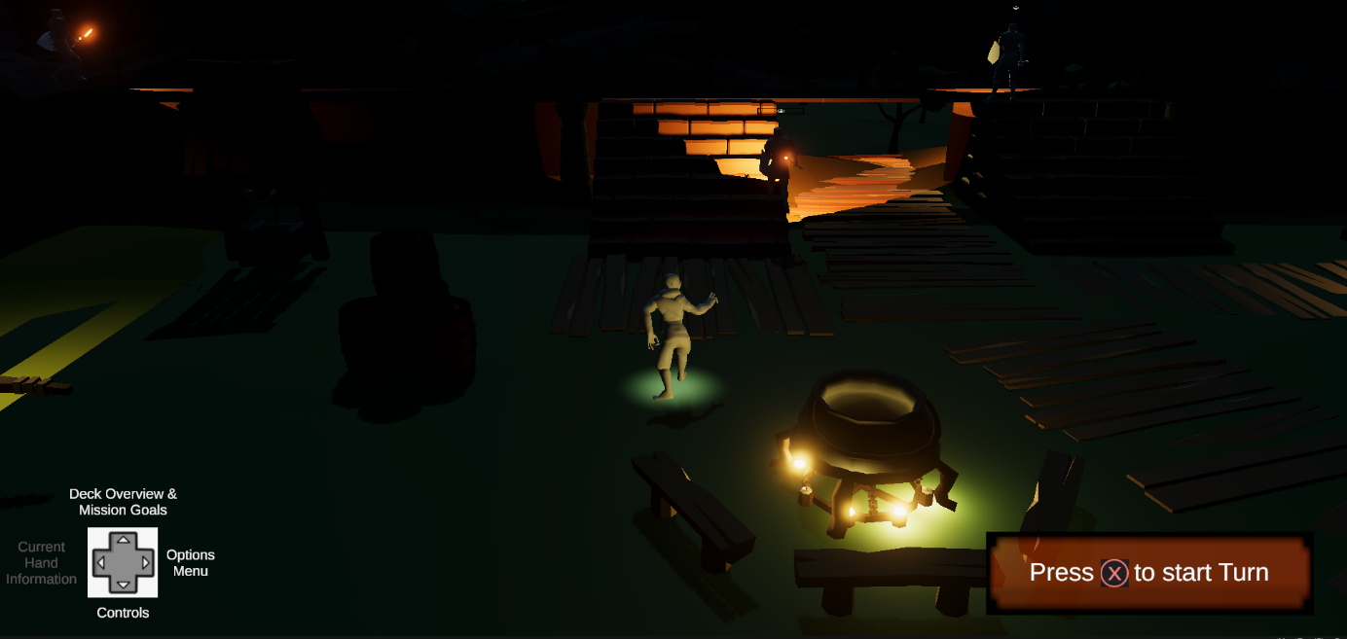

Figure 9:UI before turn was started.

* Each ‘turn’ starts with a random selection of cards drawn from the players deck (e.g., 10 different cards). The player chooses a number of cards from the selection up to a defined limit of (e.g., up to 4 cards) that fit what he’s planning to do within the upcoming turn. If the cards do not match, he can redraw once for free, if the new selection still does not fit his plans, he can redraw again but the total amount of additional redraws/turns throughout the mission is limited, depending on the difficulty settings* (chosen by the player) and the mission (chosen by the developer (me)). Throughout this whole process the game is paused

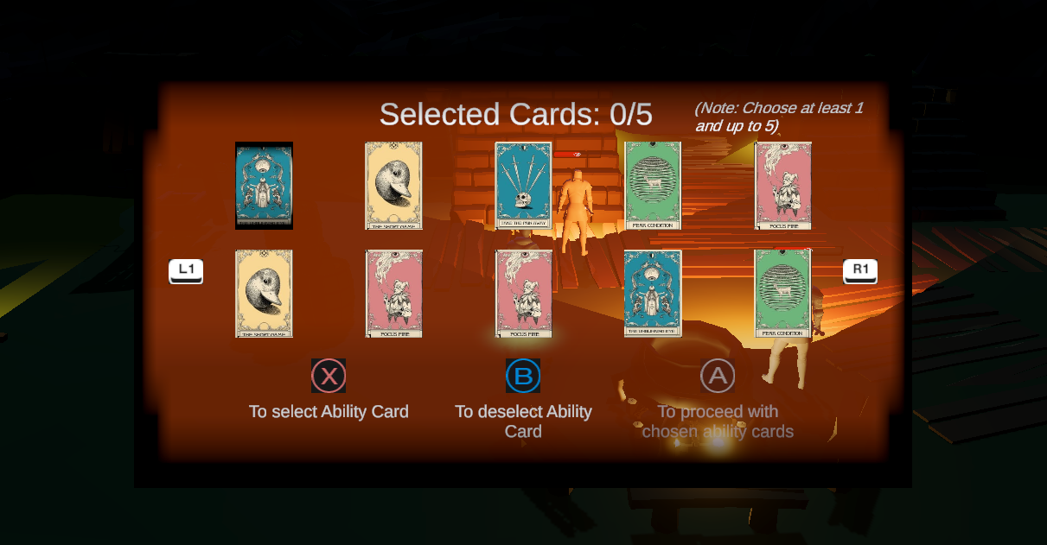

Figure 10: UI when choosing cards from random selection.

* The player is then able to move through the level in real-time, using normal controls, a range of ‘always available actions’ (like jumping, running, sneaking, etc.) and the chosen ability cards. NPCs will follow different movement patterns and activities. The player has to observe what they are doing and decide when to use the abilities properly.
* A ‘turn’ in this case is not limited to a certain time period or number of actions but just ends when the player has used up all the cards that he chose for this turn. Every turn counts as a ‘draw’ and since the player has a limited amount of ‘redraws’ throughout the level, the goal is to achieve the primary goal before reaching the last turn.

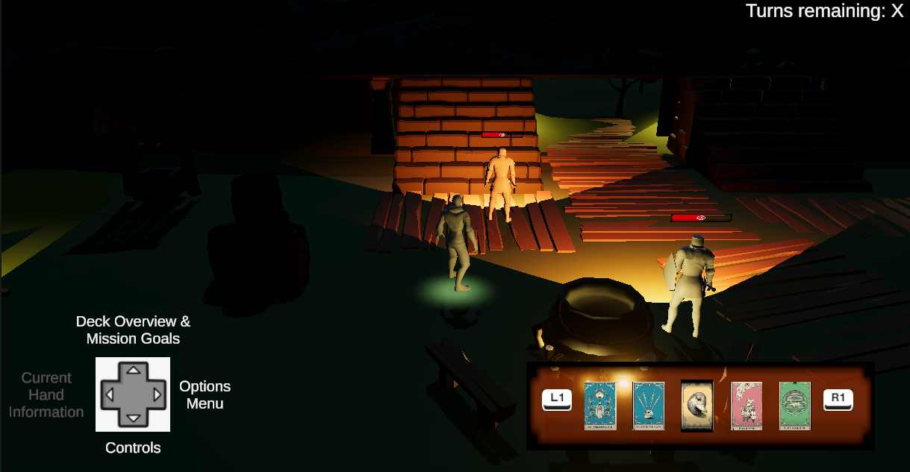

Figure 11: UI within turn (current hand information shouldnt be greyed out)

* Should they reach the last turn without getting to their goal, they will not be able to draw new cards, meaning they must complete it without using abilities or restart the level.

* The game will offer different difficulties, namely “Genin” (Easy), “Chunin” (Mediocre), “Jonin” (Hard) and “Kage” (Super Hard). These difficulties could have more complex influences but for now they will just influence the number of cards that can be drawn per turn (harder difficulty = fewer cards per turn) and the limit of turns per level (harder difficulty = fewer turns).

## Turn-Based System

The system how it was just described has a clear goal. Since the amount of turns/redraws is limited, the player could always choose the maximum possible number of cards from the selection to use as many cards as possible per turn. However, since a turn can only be finished (which relates to drawing new cards) once all equipped cards for this turn have been used it means that with picking many cards at the beginning of a turn the player risks discarding cards. As cards are removed from the deck no matter if they were used or discarded, the player is put into the position where they must find a balance between only picking the cards that they can use and not wasting turns with small numbers of abilities, because they are too picky. Summarized, the goal of this mechanic is to make the player think about possible combinations between the provided cards and how they can use them efficiently.

## Ability cards

The ability cards are probably the most unique feature of this stealth games. They are the core element, that allows players to embrace different playstyles, interact creatively with the environment and solve the puzzles within the levels in different ways.

As a result, there should be a diverse range of cards, that match different card types (as shown in Figure 8).

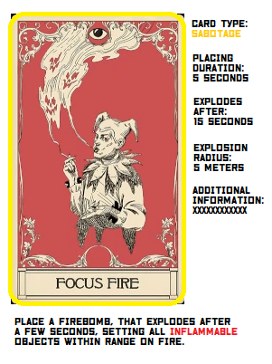

Figure 12: Example ability card

When building the deck at the players base, they should be provided with all the necessary information when choosing cards.

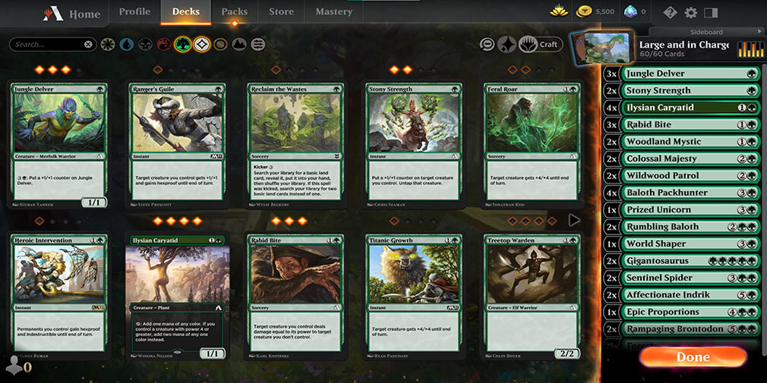

Figure 13: Example Deck building menu from MTG Arena

As seen in the example ability cards the information should include the card type as well as the information that are specific to this card.

Once the player talks to the NPC that is responsible for the ability card management, a menu should pop up that is like menus within already existing card games (see Example from MTG Arena). The menu should give information on the current assembly of their deck (which cards, how many times) and what other cards are available. It should also include an overview over the different trees of ability cards and show the progress within each tree.

To allow the player to try out different ability cards, there should be a designated area within the base where they can try them out without restrictions.

When they have built their deck, the player can start their next mission. The UI while playing should be simplistic, to make the overview as easy as possible and not distract them from what is happening. Whenever they open a menu the level is paused, to avoid that they fail a level while reading through a card or are planning what they will do next.

When the player wants to use one of their ability cards, they first select it and then hit a button to activate it. The game will then pause as well and go into a view that is specific to whatever card they are using. The view switches in color so that only the elements that this card can affect keep their color and everything else is kind of greyed out/reduced in color. If the use of the card is bound to things like a max distance, radius of effect, etc. these should be indicated as well. As soon as the player chose a fitting target, they can hit the execution button again to use the ability on this target, the game resumes and the character executes the ability automatically, choosing the shortest way to the target. Should they decide to not use the ability card, they can press a ‘cancel’ button, which cancels the ability and lets the game just resume without any actions.

After a card from the players hand was used it will disappear from the hand overview. The player can also select a card, activate it and instead of cancelling or executing it, discard it. With this the ability will only be removed from the hand without any actions.

## Other mechanics

Of course, the game will consist of many more mechanics, but in one way or another, they will always be related to the mechanics, that were just mentioned. Still, it might be worth it to at least mention some of those mechanics to show what might be possible:

* Hiding dead bodies from enemies to avoid commotion.
* Special tools like something to use ziplines (probably combined with ability cards)
* An option to analyze surroundings and classify what objects/NPCs have certain characteristics like in Assassins Creed or Shadow of Mordor
* A map of every level (should not be integrated into the ‘permanent’ UI, but being called like a menu), that allows to mark different points of interest, enemy patrolling routines, etc. It should not contain much information from the beginning, but only those that the player adds themselves or when gathering certain special information (like finding the castles patrolling schedule or a letter that describes the location of a secret door). After all, it should be tool to help orientation, not replace it.
* As mentioned earlier it is still an open decision how to include equipment into the game. The options described earlier could be a good approach, but this is something to decide in the future.

# The Prototype & Future Development plans

The attached prototype should help to deliver a feeling of the atmosphere of the game. I did my best to include the basic mechanics (sneaking, running, jumping) as well as proper camera movement (which is also controlled by the player). The prototype depicts an example level, consisting of surrounding nature, the castle, some guards patrolling and a target that must be reached to win the level. Losing is possible if the player gets detected by the guards.

Of course, the prototype touches only the surface of the game concept and nearly all the features that would make the game unique are still missing.

## Controls

The character and camera can be moved via keyboard and mouse but if possible, please use a Gamepad, as this I used it while creating the prototype and think this will work more reliable. The following table lists all the available controls:

|  |  |  |
| --- | --- | --- |
| Action | Keyboard | Gamepad |
| Character movement | W/A/S/D | Left Stick |
| Camera movement | Mouse | Right Stick |
| Switch between sneaking/running | Left shift | Press Left Stick |
| Jumping | Space | A-Button (on XBOX-Controller) |

To win the game, the player must reach the target on top of the castle.

The player loses if they are within the guard’s field of view for more than 1 second.

The player can hide behind obstacles while being in the field of view of a guard and through that won’t be seen.

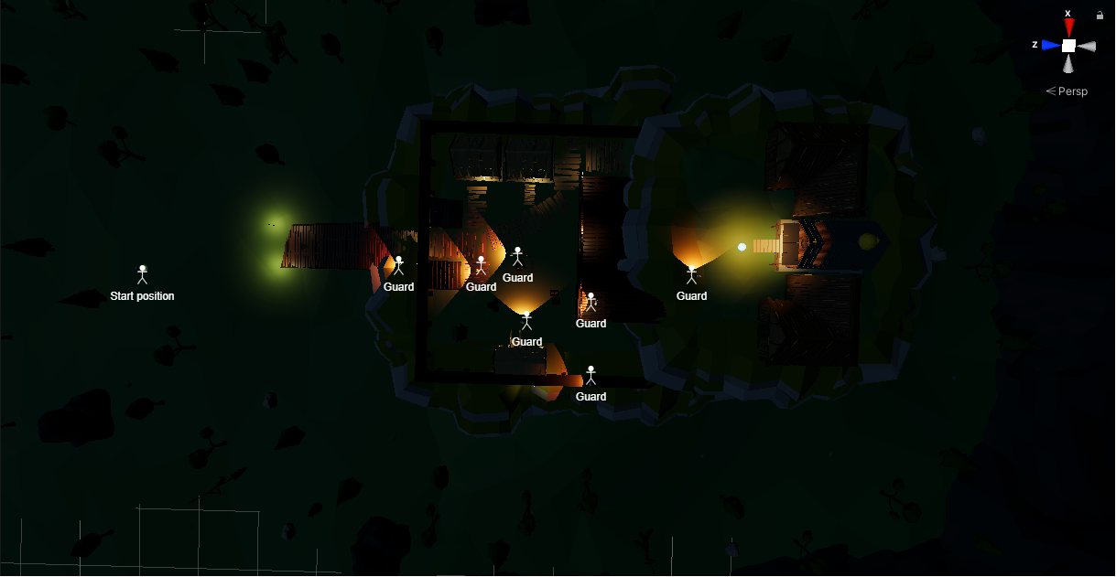

Figure 14: Top-Down view on the demo level

## Future Development Plans

While working on this project one thing became more clearly to me than ever before. To properly develop a game, it is usually best to have a team on your side. So, if the development of this game would continue, finding people to help me working on it would be my next step.

Besides that, there is of course, much more to do. First, I want to test how the mechanics and the gameplay would work out. For that I would need to implement the ability cards into the prototype, as well as a more complex level structure to put those ability into effect and give players at least a small range of possibilities and then do some playtesting to see how the mechanics are recognized.

Since I imagine the art style not to be low poly but more realistic, this would be also something to work on.

So to give a short overview over the to-do’s:

* Make art style more realistic
* Write story for act 2 & 3
* Implement core game mechanics (cards and turn based system)
* Create ALL the other levels
* Etc. etc. etc.

I have learned a lot from designing this game to implanting this prototype. It was hard and I never thought I would even get this far. But after all, this concept is only the foundation to start working. I really enjoyed it and who knows – maybe one day this game will become a real project.

# Sources

## Cover

* <https://www.wallpaperbetter.com/en/hd-wallpaper-zzcln>

## OnePager

* Background images: unfortunately, I was not able to find the images again…
* Illustration images:
  + Top left: <https://www.macgamestore.com/images_screenshots/shadow-tactics-blades-of-the-shogun-46865.jpeg>
  + Bottom second from right: <http://s01.riotpixels.net/data/18/8a/188a8316-124d-4fd1-bd9c-054ec49c1c2c.jpg.720p.jpg/artwork.shadow-tactics-blades-of-the-shogun.1280x720.2016-03-14.16.jpg>
  + Bottom right: unfortunately, I was not able to find the image again…

## Moodboard

(from top left to bottom right)

* <https://steamuserimages-a.akamaihd.net/ugc/1250260372473280500/8A12C7AC16E019C7BEBB09CA9482146E0A4B5F69/>
* <https://cdna.artstation.com/p/assets/images/images/013/237/310/large/matt-lara-mt-hiei.jpg?1538679780>
* <https://static-de.gamestop.de/images/products/268868/5scrmax1.jpg>
* <https://www.makinggames.biz/wp-content/uploads/2017/12/settings_06_theatre.jpg>
* <https://i.pinimg.com/originals/53/41/d2/5341d24151ab8f87ddec9175a9499748.jpg>
* <https://i.pinimg.com/originals/2e/82/05/2e8205919cc80d9712a4c1db68741f58.jpg>

## Dramatic Tools

* <https://i.ytimg.com/vi/40Ek05sJzUg/maxresdefault.jpg>
* <https://www.augsburger-allgemeine.de/img/panorama/crop57186696/1256427762-cv16_9-w1200/GOT-Screen-PS4Pro-4K-E32018-00002-1528773460.jpg>
* <https://www.gamereactor.de/media/08/ghosttsushima_3200883b.png>
* <https://hdwallpaperim.com/wp-content/uploads/2017/08/24/108171-Total_War_Shogun_2-samurai.jpg>

## Mechanics

* <https://media.pocketgamer.com/artwork/na-32382-1611916609/MTG%20Arena%20decks%201.jpg> (picture source: Deck building example) (Original game: MTG Arena)

## Prototype

* The following tutorials were used:
  + <https://www.youtube.com/watch?v=_QajrabyTJc&t=1018s>
  + <https://www.youtube.com/watch?v=4HpC--2iowE&t=10s>
  + <https://www.youtube.com/playlist?list=PLwyUzJb_FNeTQwyGujWRLqnfKpV-cj-eO>
  + <https://www.youtube.com/watch?v=jUdx_Nj4Xk0&t=697s>
* The following assets from the asset store were used:
  + <https://assetstore.unity.com/packages/vfx/particles/3d-games-effects-pack-free-42285>
  + <https://assetstore.unity.com/packages/2d/textures-materials/sky/allsky-free-10-sky-skybox-set-146014>
  + <https://assetstore.unity.com/packages/3d/environments/landscapes/low-poly-cliff-pack-67289>
  + <https://assetstore.unity.com/packages/3d/props/low-poly-crates-80037>
  + <https://assetstore.unity.com/packages/3d/props/exterior/low-poly-fence-pack-61661>
  + <https://assetstore.unity.com/packages/3d/environments/low-poly-free-vegetation-pack-176906>
  + <https://assetstore.unity.com/packages/templates/packs/low-poly-game-kit-110455>
  + <https://assetstore.unity.com/packages/3d/environments/low-poly-mini-village-free-131677>
  + <https://assetstore.unity.com/packages/3d/environments/low-poly-rock-pack-57874>
  + <https://assetstore.unity.com/packages/3d/environments/landscapes/low-poly-simple-nature-pack-162153>
  + <https://assetstore.unity.com/packages/3d/vegetation/trees/low-poly-tree-pack-57866>
  + <https://assetstore.unity.com/packages/3d/prototyping-pack-free-94277>
  + <https://assetstore.unity.com/packages/3d/environments/landscapes/rpg-poly-pack-lite-148410>
  + <https://assetstore.unity.com/packages/p/ultimate-low-poly-dungeon-143535>
* The following other assets were used:
  + Character (and guards) models & animations from <https://www.mixamo.com/>
  + <https://i.ytimg.com/vi/hsX076drCOE/maxresdefault.jpg> (picture source) (original game: Red Dead Redemption 2)
  + <https://m.media-amazon.com/images/G/01/mobile-apps/dex/firetv/button-hints._TTH_.png> (other Gamepad button images)